Confidential and Proprietary Information

SimpleVoIP SureDial  
Install Guide

Table of Contents

Overview 2

Preparation & REQUIRED Equipment 3

Required Tools 3

Confirm Site is Ready 3

Step by Step Installation Guide 4

2: Activating the unit 5

3: Find the correct POTS lines for Fire and Security Alarms 5

4: Relocate the POTS lines for Fire and Security Alarms to the Unit 6

5: Test Fire/Burg Alarm 7

Test Fire/Burg Alarm Cont. 8

6: Install phones or other analog voice devices 8

7: Test Calls 9

# Overview

|  |  |
| --- | --- |
|  | This guide covers preparation, onsite installation, testing and verification/QA of SimpleVoIP devices and services. |

The Ooma AirDial in a Box system is an LTE cellular modem that operates as a Pots Replacement and lifeline device. The Ooma AirDial will be able to pass information along the primary WAN circuit and convert it to an analogue signal for use with alarms, telephones, safes, elevators and more. This device will switch to cellular in the event of a WAN outage and also has a built-in battery to continue to supply power to the end devices in the case of a power outage unlike standard ATAs. This guide will show you the most common installation types Ooma AirDial.

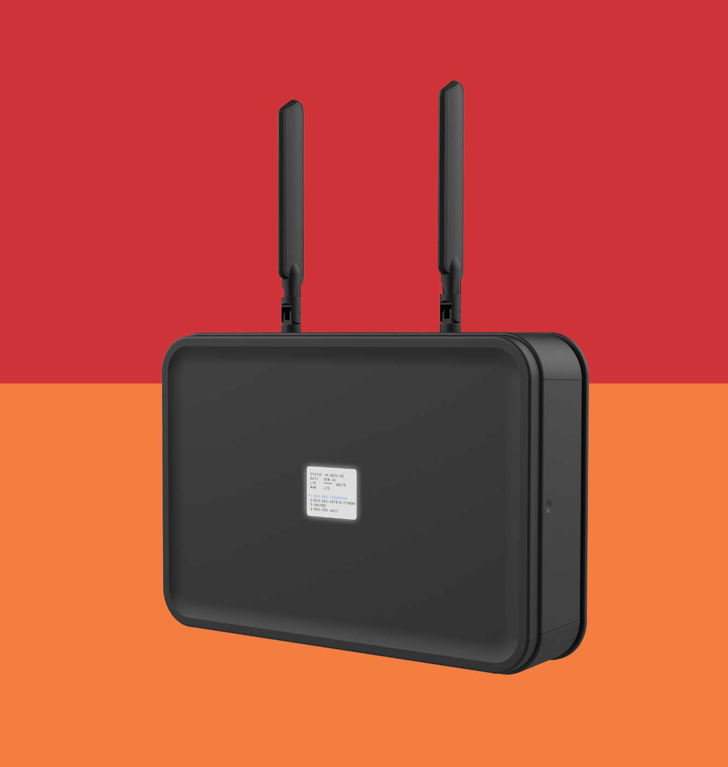

# Preparation & REQUIRED Equipment

## Required Tools

|  |  |
| --- | --- |
|  | Technician shall arrive prepared with the following tools: |

|  |  |
| --- | --- |
| * Laptop   + Wi-Fi capable   + Available ethernet port or USB ethernet adapter   + Web browser * Cable toner/tester * Label Maker * Ladder * Extension cord | * Drill/Driver with Phillips head   + Wood, metal, & masonry screws   + Screwdrivers (phillips & slotted) * Additional cat5 cable   + RJ45 ends and crimper * Additional phone cable   + RJ11 ends and crimper * Velcro straps/zip ties * Biscuit Jacks |

## Confirm Site is Ready

Verify the items you’ll be connecting to the Ooma AirDia. Not all of those listed are applicable for your installation.

* Verify Ooma AirDial is onsite and ready to be installed
* Locate the DEMARC and the 66 Block
  + Determine if you have access to the 66 Block and the Network in the same room, or if additional cables will need to be run in order to connect the phone lines for the alarm and phones to the Ooma AirDia which should be installed near the Network
* Locate the fire/burg alarm
  + Verify the alarms are in test mode (*Store’s MOD may need to help with this step*)
* Locate the analog phones
  + Verify that they are currently working on their existing POTS connection prior to transformation
* Locate the fax machine
  + Verify it is able to send or receive prior to transformation
* Repeat as needed for any other analog voice service you’re connecting to the Ooma AirDia

# Step by Step Installation Guide

Mount the Ooma Airdial to a wall where the reception is ideal, the device is clearly visible and able to be reached by store employees for troubleshooting in the future. **DO NOT** place the Ooma Airdial inside any network rack or between metal conduit as this will impact cellular reception.

## 2: Activating the unit

 Get the device plugged into power and have it start to boot up

 On the back of the device there is an activation code, call into the support line to activate 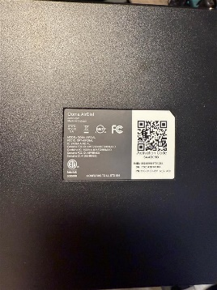

 Power cycle the device after the device has been activated and confirm it shows numbers on the lines

## 3: Find the correct POTS lines for Fire and Security Alarms



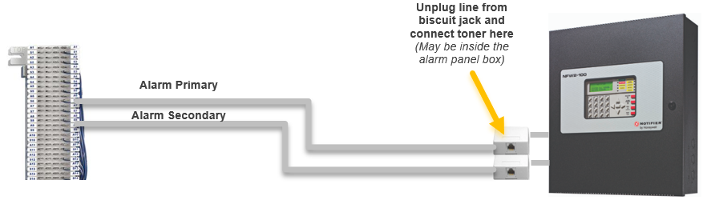Confirm with the MOD that the Fire Alarm is in TEST mode

**Unplug line from biscuit jack and connect toner here***(May be inside the alarm panel box)*

**Alarm Primary**

**Alarm Secondary**



* Starting from the Fire Panel, trace the POTS lines back to the 66 block to see where they are punched down



* Tone-trace the existing cabling
  1. Temporarily unplug the cable from the Fire Alarm Panel leading into one of the RJ-31x surface mount jacks.
  2. Plug tone-generator into the surface mount jack to tone-out the cabling back towards the Demarc to discover its location. Repeat for other RJ-31x jack/cable too if needed.
  3. Restore connection to RJ-31 jack(s)



* Label each line accordingly (Alarm Primary, Alarm Secondary)

## 4: Relocate the POTS lines for Fire and Security Alarms to the Unit

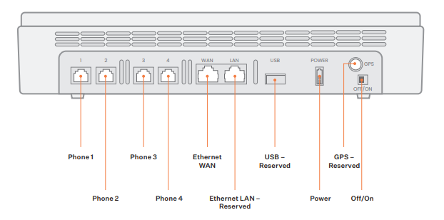

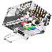

**Alarm Primary**

**Alarm Secondary**

* Remove Alarm Primary from the 66 block and attach a new RJ11 male connection to the end. Then plug the new RJ11 end into one of the provided new biscuit jacks. Using the provided patch phone cables plug into the biscuit jack and terminate at RJ11 Port #1 on the Ooma Airdial.
* Remove Alarm Secondary from the 66 block and attach a new RJ11 male connection to the end. Then plug the new RJ11 end into one of the provided new biscuit jacks. Using the provided patch phone cables plug into the biscuit jack and terminate at RJ11 Port #2 on the Ooma Airdial.
  1. If the phone lines won’t reach the Ooma AirDia, you may need to run new phone cable from the Ooma Airdial to the biscuit jacks patching to the Fire Panel.
  2. Mount the biscuit jacks to the wall where they are accessible for future troubleshooting needs.

## 5: Test Fire/Burg Alarm



The first alarm call may fail during the auto-detect sequence, this is normal. If calls continue to fail, contact installation support.

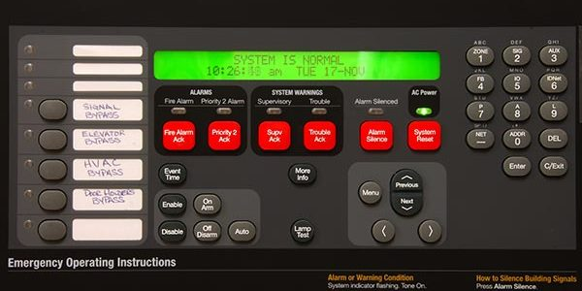



* Determine if the Alarm Panel has a current Trouble condition *(Controller display a message or LED Indicators)* and note or take a picture then go back to the Ooma Airdial.





* Invoke Alarm Panel into a Trouble Condition:
  1. Remove phone cords from Alarm line 1 & 2 jacks of the Ooma Airdial Device unit and leave disconnected for at least 3 minutes.
  2. If time permits, walk back to Alarm Panel to wait for it to go into Trouble condition as may be indicated in Controller Display and/or via certain LED indicators being lit on Motherboard.



* Secondary line testing
  1. Only plug secondary phone cord back into line 2, wait for green led to go from flashing to solid, the system has attempted to make a call *(SimpleVoIP dispatch will verify in customer call history).*

## Test Fire/Burg Alarm Cont.



* Primary line testing
  1. Plug primary phone cord back into line 1, wait for green led to go from flashing to solid, the system has attempted to make a call.



* Fire Panel confirmation
  1. Confirm the panel has cleared the trouble condition, if all calls successful and trouble condition cleared, customer will contact alarm company to place panel back into normal operation.



The Store Manager or alarm company should now arm the alarm.

* 1. Trigger an alarm to test the zones are working properly.



* Standby: The alarm company will need to make sure that the correct alarm lines/zones have been triggered.
  1. The alarm company may remote into the alarm to make any necessary changes.
* Once verified that the alarm is working properly, the alarm should be taken out of test mode.
  1. The alarm is now live. Make sure the Store Manager is aware that the alarm is live and functional.

## 6: Install phones or other analog voice devices



* A picture containing text, electronics, indoor, different

  Description automatically generated
* A satellite view of a city

  Description automatically generated with low confidenceA satellite view of a city

  Description automatically generated with low confidenceA satellite view of a city

  Description automatically generated with low confidence

**MGR Office**

* A picture containing text, jack, electronics

  Description automatically generated

**Phone #1**

* A picture containing text, electronics, indoor, different

  Description automatically generated
* A close-up of a calculator

  Description automatically generated with low confidence
* A picture containing text, jack, electronics

  Description automatically generated

**Phone #2**

* 

**Host Stand**

* A fax machine with a cord

  Description automatically generated with low confidenceA picture containing text, jack, electronics

  Description automatically generated

**Phone #3**

**Fax Machine**

**66 Block**



* Tone & trace the existing phone cabling to plug the lines into the correct ports.
  1. Find line #1 *(Manager’s phone for example)* and plug a tone generator into the wall port that this phone is using. Then come back to the 66 Block and find where that line is punched down. Label this line appropriately  
     *(Repeat for all other analog phone lines being transformed from POTS to Pots in a Box)*
* 
* Transfer the phone lines from the 66 block into the phone ports on the Ooma Airdial to provide dial tone to the ports the phones will be using as outlined in the diagram above.
  1. Remove line 1 cable from 66 Block, attach an RJ11 male plug to the end and plug directly into Phone Port #1 on the Ooma Airdial.  
     *(Repeat for all other analog phone lines being transformed from POTS to Pots in a Box*

## 7: Test Calls

* 
* Now that the phone lines have been swung from the 66 Block into the Ooma Airdial, the phones should have service at their wall jacks.
  1. Pick up a phone and test the dialtone.
  2. Place a test outbound call to your cell phone. You should see the store’s main phone number on your caller ID.
  3. Place a test call to the store’s main phone number from your cell phone to verify that inbound calls reach the unit and the analog phones.
* Test the cellular backup to ensure the phones work on the Ooma Airdial e only.

* 1. Unplug the ethernet cable leading into the Ooma Airdial from the WAN and verify the cellular connection is on.
  2. Pick up a phone and test the dialtone.
  3. Place a test outbound call to your cell phone. You should see the store’s main phone number on your caller ID.
  4. Place a test call to the store’s main phone number from your cell phone to verify that inbound calls reach the unit and the analog phones.



* Replace the ethernet cable from the WAN into the Ooma Airdial.